**9. ReactJS – HOL**

Estimated time to complete this lab: **60 minutes.**

Create a React Application named “cricketapp” with the following components:

1. ListofPlayers

* Declare an array with 11 players and store details of their names and scores using the map feature of ES6

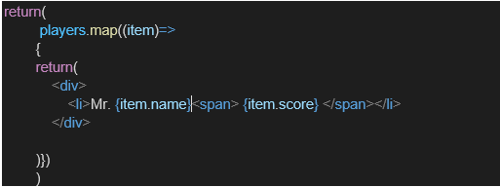

* Filter the players with scores below 70 using arrow functions of ES6.

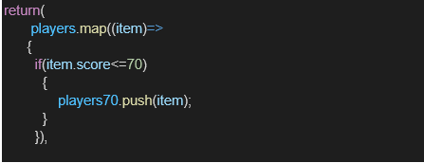

1. IndianPlayers
   1. Display the Odd Team Player and Even Team players using the Destructuring features of ES6

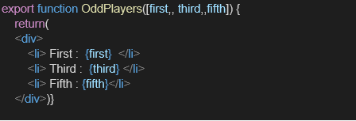

* 1. Declare two arrays T20players and RanjiTrophy players and merge the two arrays and display them using the Merge feature of ES6

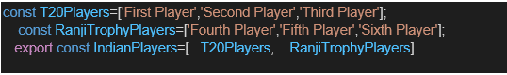

Display these two components in the same home page using a simple if else in the flag variable.

**Output:**

When Flag=true

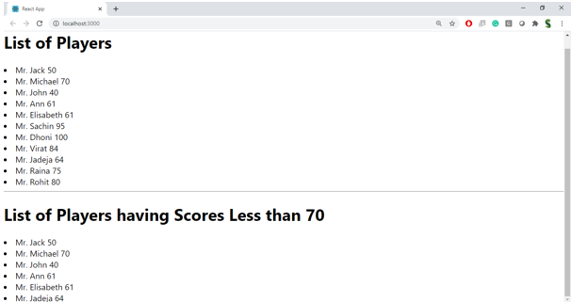

When Flag=false

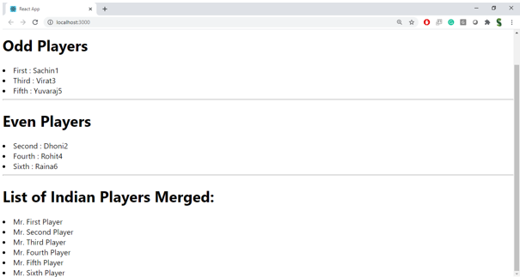

**Hint:**

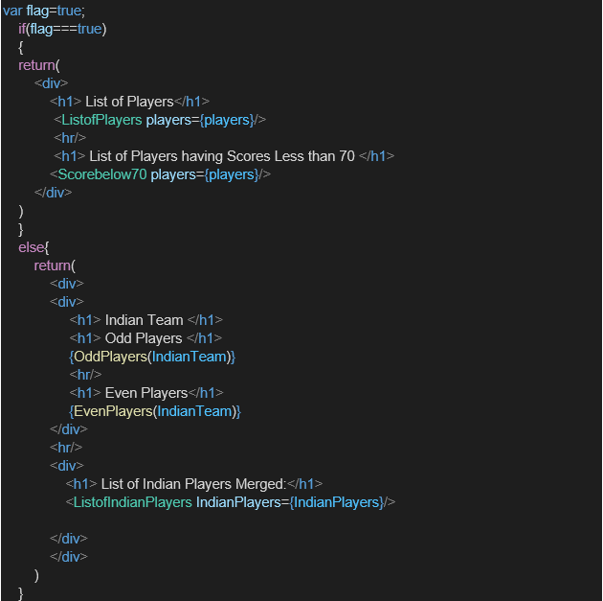

**Source Code:**

**App.js:**

import './App.css';

import ListOfPlayers from './ListOfPlayers'

import ListOfPlayers70 from './ListOfPlayers70';

// import {useState} from 'react';

import ListOfIndianPlayers from './ListOfIndianPlayers'

function OddPlayers([first,,third,,fifth]){

  return(

    <ul>

      <li>First : {first}</li>

      <li>Third : {third}</li>

      <li>Fifth : {fifth}</li>

    </ul>

  )

}

function EvenPlayers([,second,,fourth,,sixth]){

  return(

    <ul>

      <li>Second : {second}</li>

      <li>Fourth : {fourth}</li>

      <li>Sixth : {sixth}</li>

    </ul>

  )

}

function App() {

  var players=[['Mr. Jack',50],["Mr. Michael",70],["Mr. John",40],["Mr. Ann",61],["Mr. Elisabeth",61],["Mr. Sachin",95],["Mr. Dhoni",100],["Mr. Virat",84],["Mr. Jadeja",64],["Mr. Raina",75],["Mr. Rohit",80]]

  var T20Players=['First Player','Second Player','Third Player']

  var RanjiTrophy=['Fourth Player','Fifth Player','Sixth Player']

  var IndianPlayers=[...T20Players,...RanjiTrophy]

  var IndianTeam=['sachin1','dhoni2','virat3','rohith4','yuvraj5','raina6']

  var flag=true

      if(flag===true){

        return(

          <div>

            <ListOfPlayers players={players}/>

            <hr/>

            <ListOfPlayers70 players={players}/>

          </div>

        )

      }else{

        return(

          <div>

            <div>

              <h1>Indian Players</h1>

              <h1>Odd Players</h1>

              {OddPlayers(IndianTeam)}

              <h1>Even Players</h1>

              {EvenPlayers(IndianTeam)}

            </div>

            <hr/>

            <div>

              <h1>List Of Indian Players Merged</h1>

              <ListOfIndianPlayers players={IndianPlayers}/>

            </div>

          </div>

        )

      }

}

export default App;

**ListOfIndianPlayers.js:**

function ListOfIndianPlayers(props){

    return(

        <>

        <ul>{

            props.players.map((item,index)=>{

                return(

                    <li key={index}>

                        <span>Mr. </span><span>{item}</span>

                    </li>

                )

            })}

        </ul>

        </>

    )

}

export default ListOfIndianPlayers;

**ListOfPlayers.js:**

function ListOfPlayers(props){

    return (

        <div>

            <h1>

            List Of Players

            </h1>

            <ul>

            {

                props.players.map((item,index)=>{

                    return(

                        <li key={index}><span>{item[0]} </span><span>{item[1]}</span></li>

                    )

                })

            }

            </ul>

        </div>

    )

}

export default ListOfPlayers;

**ListOfPlayers70.js:**

function ListOfPlayers70(props){

    const filtered = props.players.filter(player => player[1] <= 70);

    return(

        <div>

            <h1>List Of Players Having Scores Less than 70</h1>

            {

                filtered.map((item,index)=>{

                    return(

                        <div>

                            <li key={index}>

                                <span>{item[0]} </span><span>{item[1]}</span>

                            </li>

                        </div>

                    )

                })

            }

        </div>

    )

}

export default ListOfPlayers70;

**Output:**

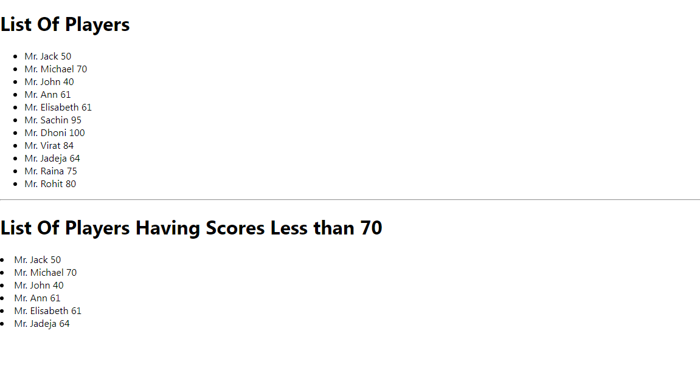when flag ===true:

**when flag===false:**

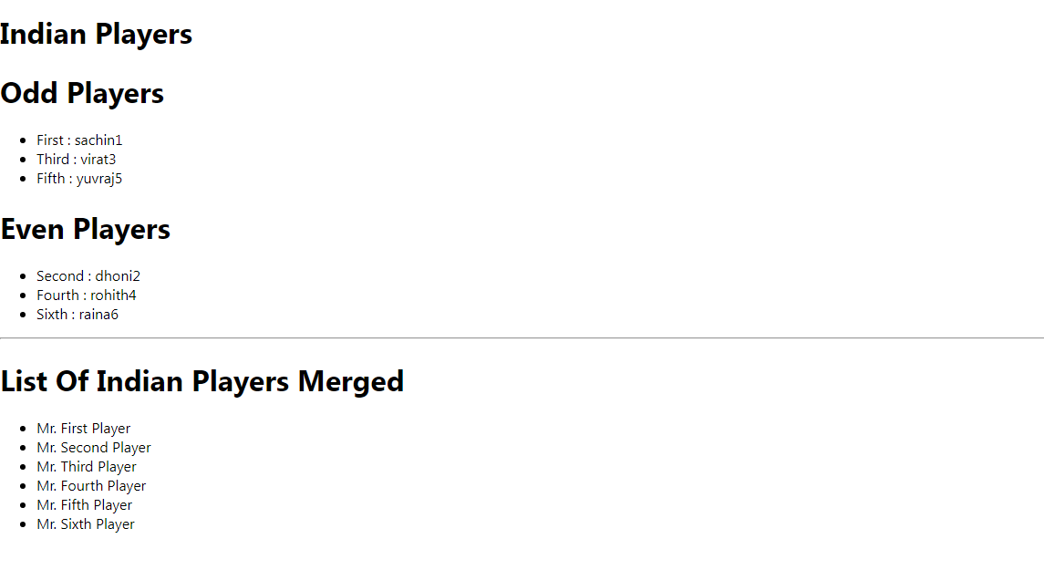**10.ReactJS – HOL**

Estimated time to complete this lab: **60 minutes.**

Create a React Application named “officespacerentalapp” which uses React JSX to create elements, attributes and renders DOM to display the page.

Create an element to display the heading of the page.

Attribute to display the image of the office space

Create an object of office to display the details like Name, Rent and Address.

Create a list of Object and loop through the office space item to display more data.

To apply Css, Display the color of the Rent in Red if it’s below 60000 and in Green if it’s above 60000.

Output:

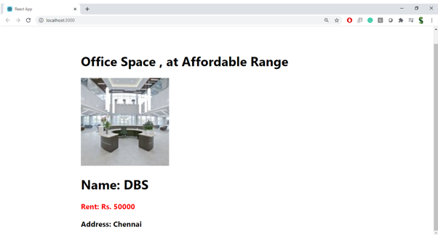

**Hint:**

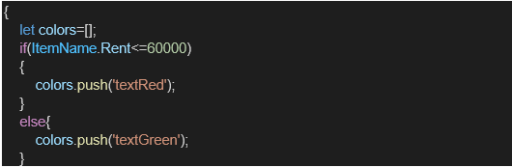

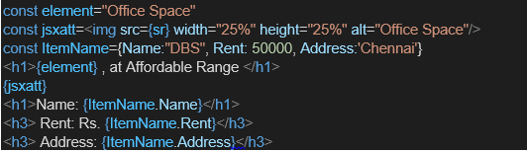

**Source Code:**

**App.js**

import './App.css';

function getColor(rent){

  return rent>60000?'green':'red'

}

function App() {

  const element="Office Space"

  const jsxatt=<img src="download.jpg" width="25%" height="25%" alt="Office Space"/>

  const ItemName={Name:"DBS",Rent:50000,Address:'Chennai'}

  return (

    <div className="App">

      <h1>{element},at Affordable range</h1>

      {jsxatt}

      <h1>Name: {ItemName.Name}</h1>

      <h3 style={{color:getColor(ItemName.Rent)}}>Rent: {ItemName.Rent}</h3>

      <h3>Address: {ItemName.Address}</h3>

    </div>

  );

}

export default App;

**App.css**

.App{

  display:flex;

  justify-content: center;

  text-align: center;

}

**Download.jpg**



**Output:**

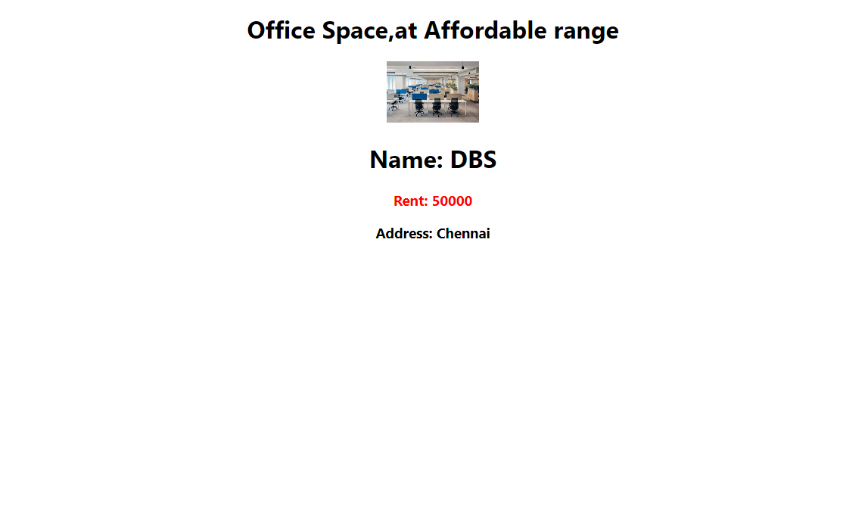

**11.ReactJS – HOL**

Create a React Application “eventexamplesapp” to handle various events of the form elements in HTML.

1. Create “Increment” button to increase the value of the counter and “Decrement” button to decrease the value of the counter. The “Increase” button should invoke multiple methods.
   1. To increment the value
   2. Say Hello followed by a static message.

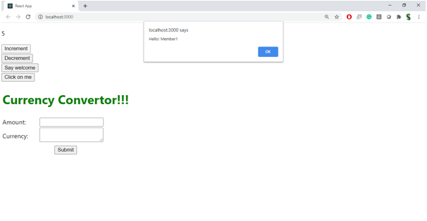

1. Create a button “Say Welcome” which invokes the function which takes “welcome” as an argument.

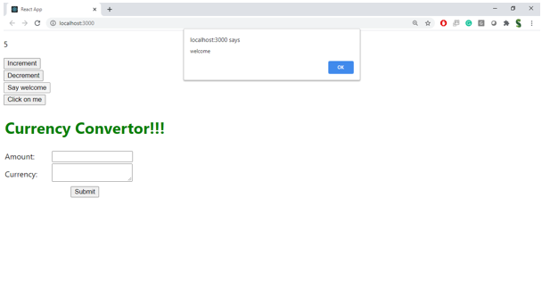

1. Create a button which invokes synthetic event “OnPress” which display “I was clicked”

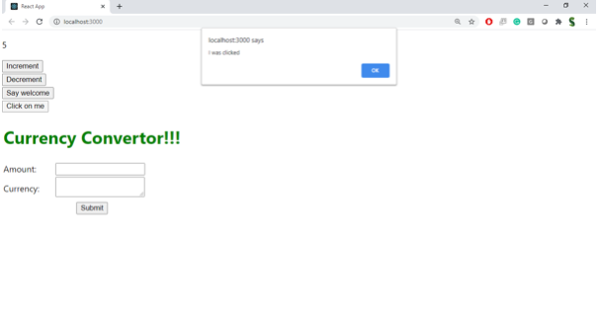

Create a “CurrencyConvertor” component which will convert the Indian Rupees to Euro when the Convert button is clicked.

Handle the Click event of the button to invoke the handleSubmit event and handle the conversion of the euro to rupees.

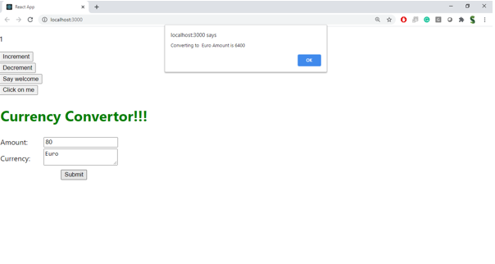

**Source Code:**

**App.js**

import './App.css';

import {useState} from 'react'

function handleSubmit(e){

e.preventDefault();

const euroAmount=e.target.currency.value*0.0099;

return(

window.alert(`Converting to Euro Amount is ${euroAmount.toFixed(2)}`)

)

}

function App() {

const [value,setValue]=useState(0)

const [currency,setCurrency]=useState(0);

const [currencyType,setCurrencyType]=useState("");

return (

<div className="App">

<p>{value}</p>

<button onClick={()=>{setValue(value=>value+1);window.alert("Hello Member");}}>Increment</button><br/>

<button onClick={()=>setValue(value=>value-1)}>Decrement</button><br/>

<button onClick={()=>{window.alert("Welcome")}}>Say Welcome</button><br/>

<button onClick={()=>{window.alert("I Was Clicked")}}>OnPress/ClickOnMe</button><br/>

<h1 style={{color:'green'}}>Currency Converter!!!</h1><br/>

<form onSubmit={handleSubmit}>

<label>Amount</label><input type="number" name="currency" value={currency} onChange={(e)=>{setCurrency(e.target.value)}}/><br/>

<label>Currency</label><input type='text' name="currencyType" value={currencyType} onChange={(e)=>{setCurrencyType(e.target.value)}}/><br/>

<button type="submit">Handle Submit</button>

</form>

</div>

);

}

export default App;

**Output:**

Click On Increment Button  
Method 1:

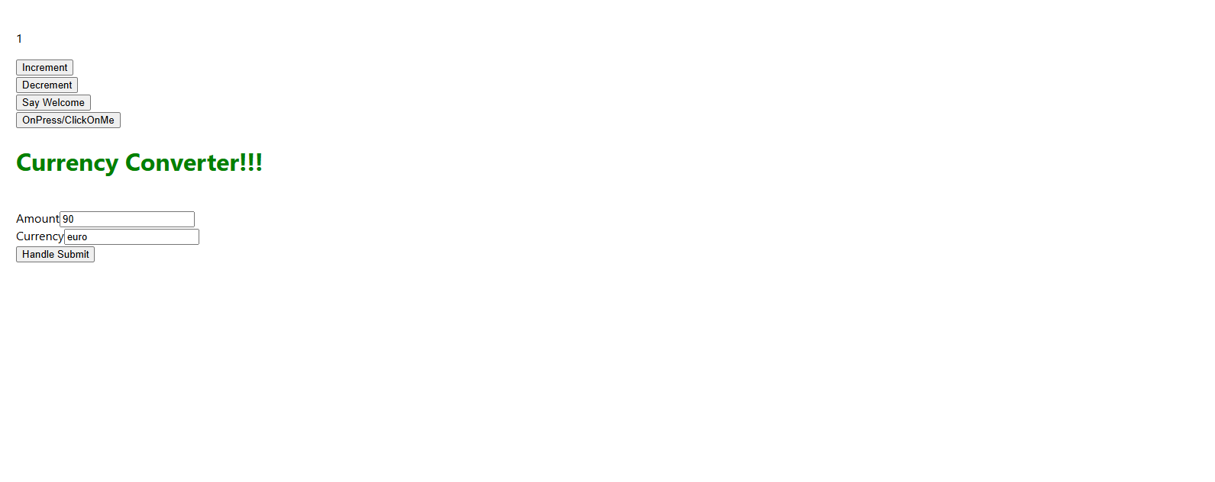  
Method 2:

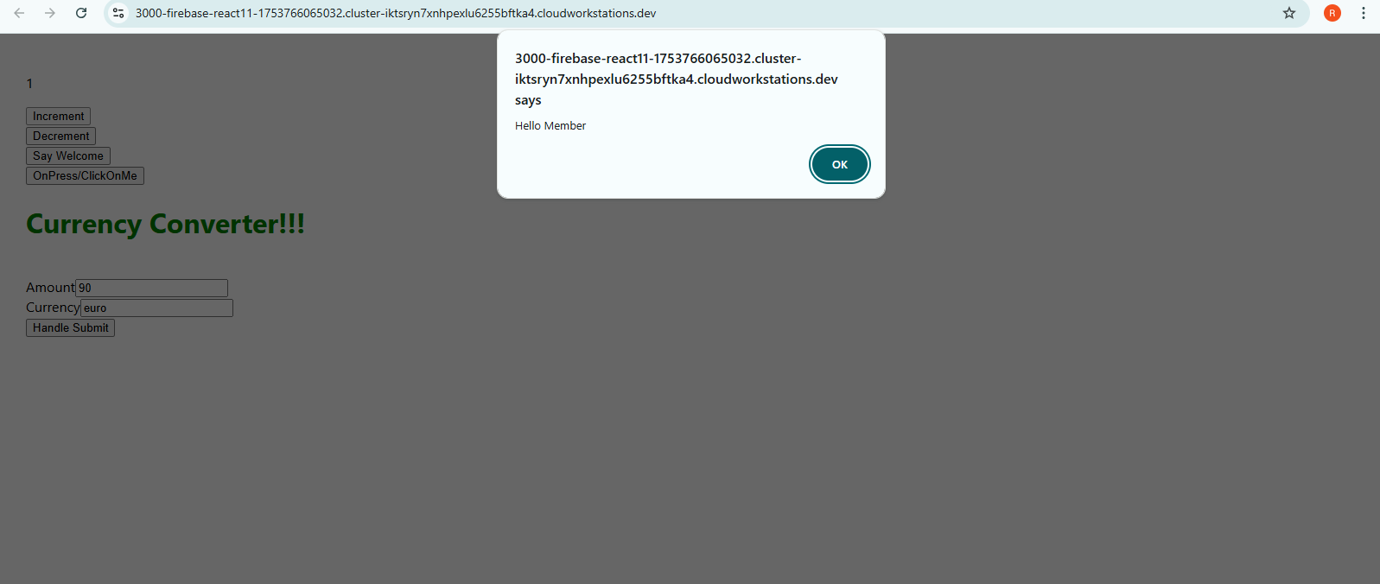

\

Click On Decrement Button  
  
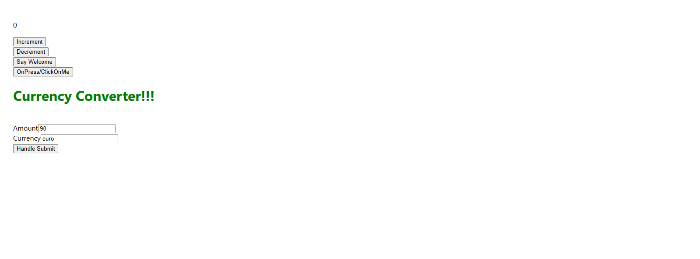  
Click On Say Welcome Button  
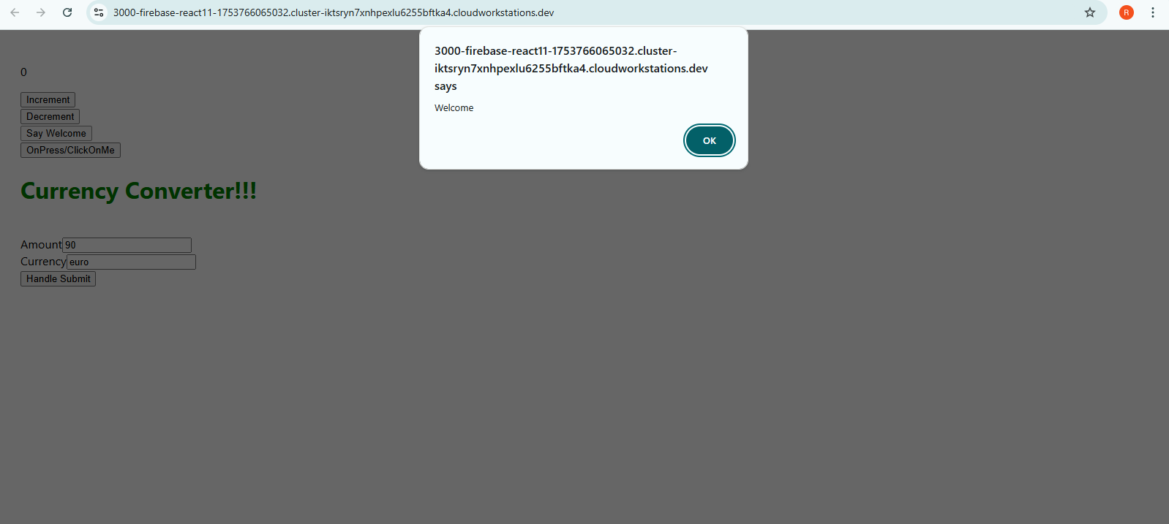

Click On OnPress/ClickOnMe Button  
  
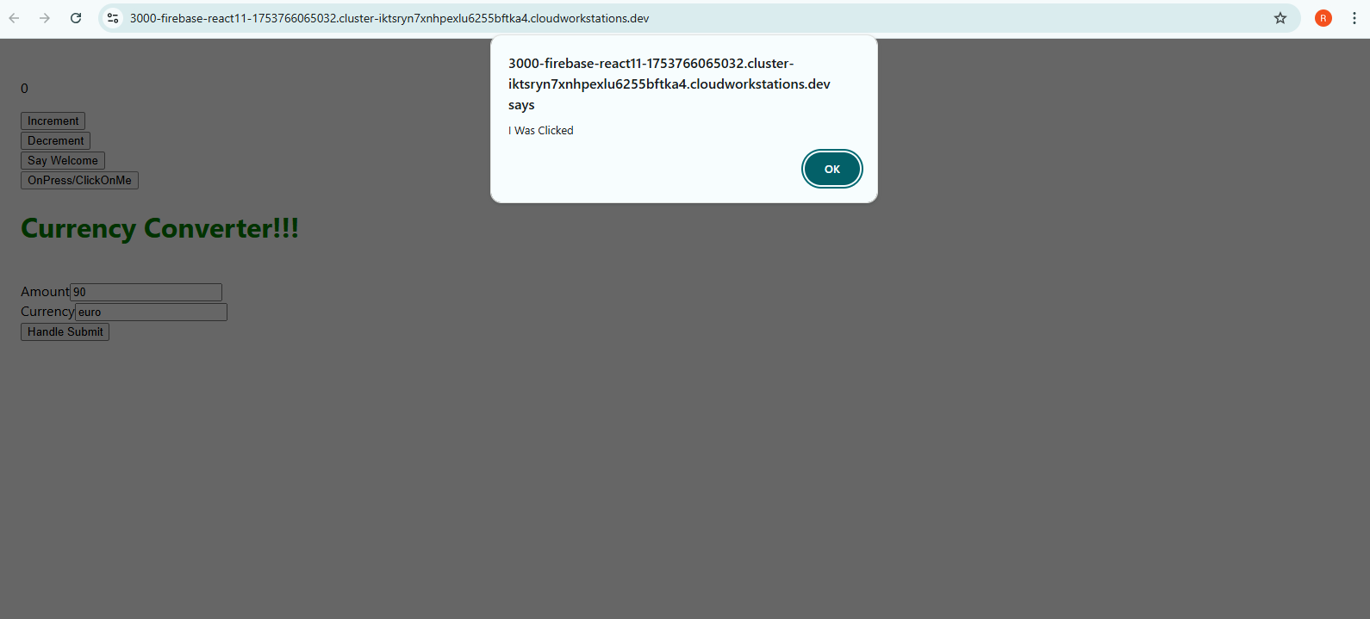

Currency Convertor

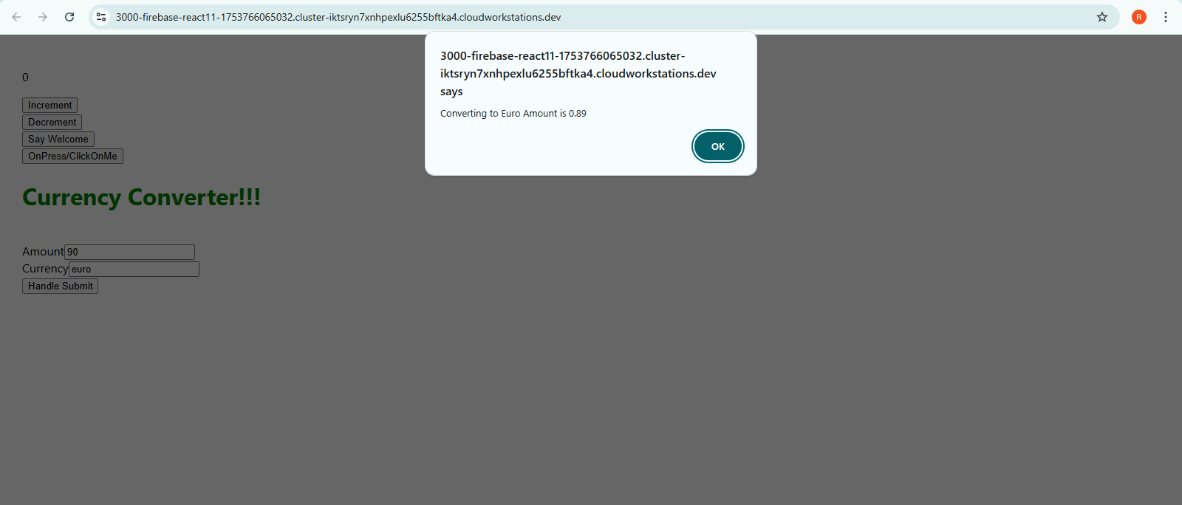

**12.ReactJS - HOL**

Create a React Application named “ticketbookingapp” where the guest user can browse the page where the flight details are displayed whereas the logged in user only can book tickets.

The Login and Logout buttons should accordingly display different pages. Once the user is logged in the User page should be displayed. When the user clicks on Logout, the Guest page should be displayed.

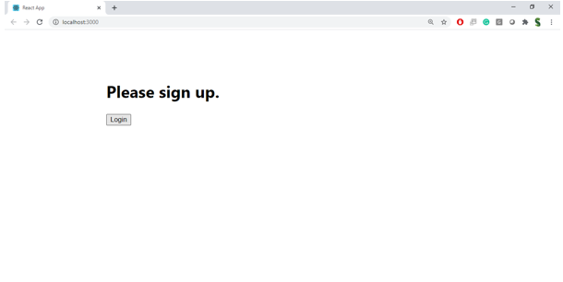

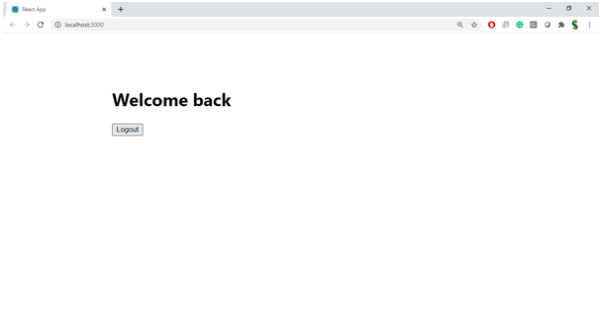

**Hint:**

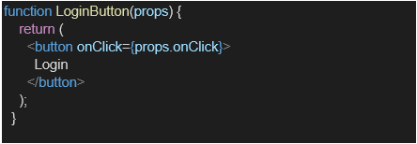

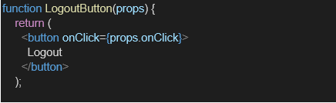

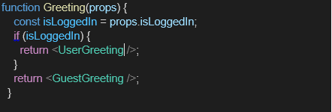

**Source Code:**

**App.js:**

import './App.css';

import {useState} from 'react';

import UserGreeting from './UserGreeting';

import GuestGreeting from './GuestGreeting';

function App() {

const [isLoggedIn,setLoggedIn]=useState(false)

return (

<div className="App">

{isLoggedIn?

<UserGreeting/>:<GuestGreeting/>}

<button onClick={()=>setLoggedIn(isLoggedIn=>!isLoggedIn)}>{isLoggedIn?"Logout":"Login"}</button>

</div>

);

}

export default App;

**UserGreeting.js:**  
function UserGreeting(){

return(

<>

<h1>

Welcome Back!!

</h1>

<h2>Book Your Tickets:</h2>

<ul>

<li>

Flight 101: <button name="Flight-101" onClick={()=>alert("Flight 101 Booked")}>Book</button>

</li>

<li>

Flight 202: <button name="Flight-202" onClick={()=>alert("Flight 202 Booked")}>Book</button>

</li>

<li>

Flight 303: <button name="Flight-303" onClick={()=>{alert("Flight 303 Booked")}}>Book</button>

</li>

</ul>

</>

)

}

export default UserGreeting;

**GuestGreeting.js:**

function GuestGreeting(){

return(

<>

<h1>

Please Login-In

</h1>

<h2>Available Flights:</h2>

<ul>

<li>Flight 101: Mumbai to Delhi - 10:00 AM</li>

<li>Flight 202: Bangalore to Hyderabad - 1:00 PM</li>

<li>Flight 303: Chennai to Kolkata - 5:00 PM</li>

</ul>

</>

)

}

export default GuestGreeting;

**Output:**  
  
While Logout:  
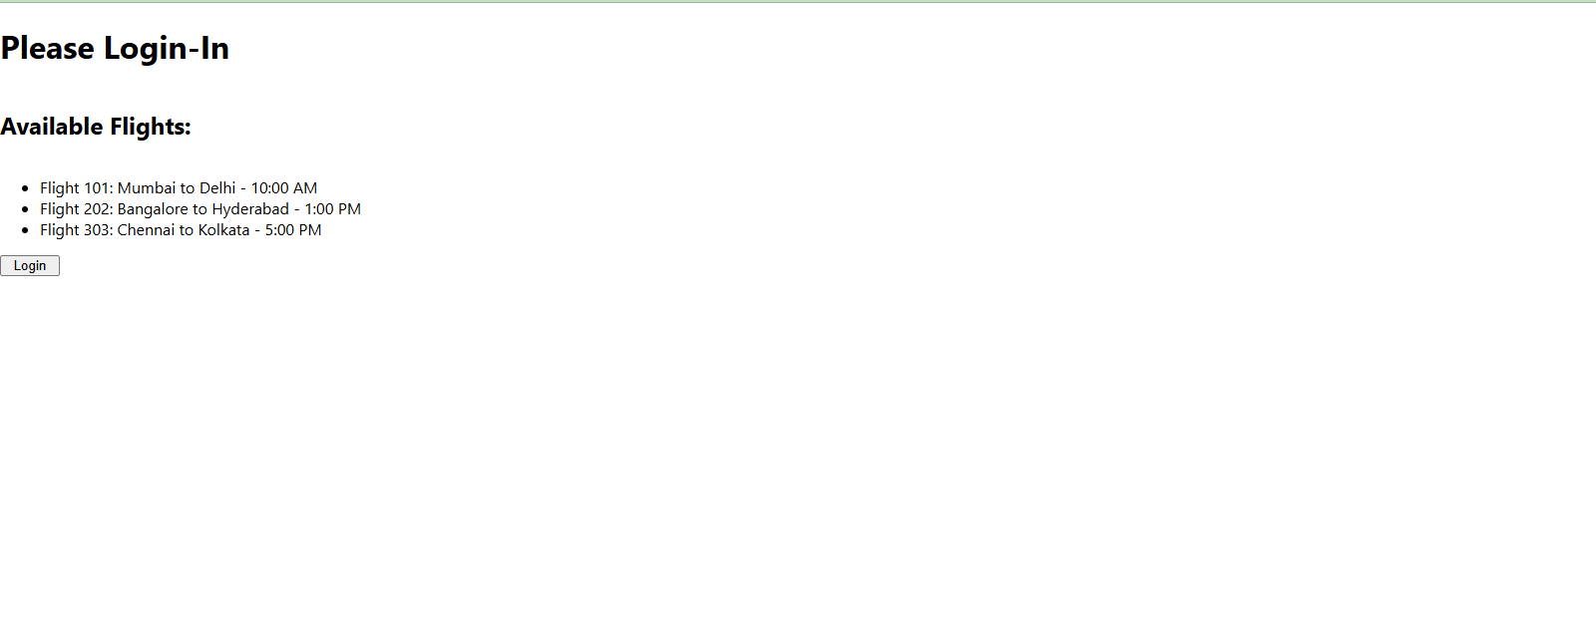

While Login:

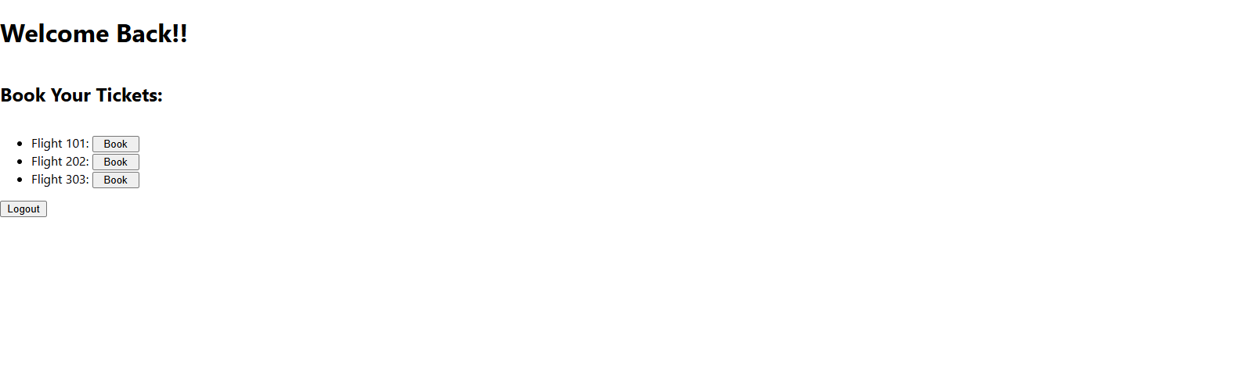

When the 'Book' button is clicked for any flight, it should display the respective alert message.  
  
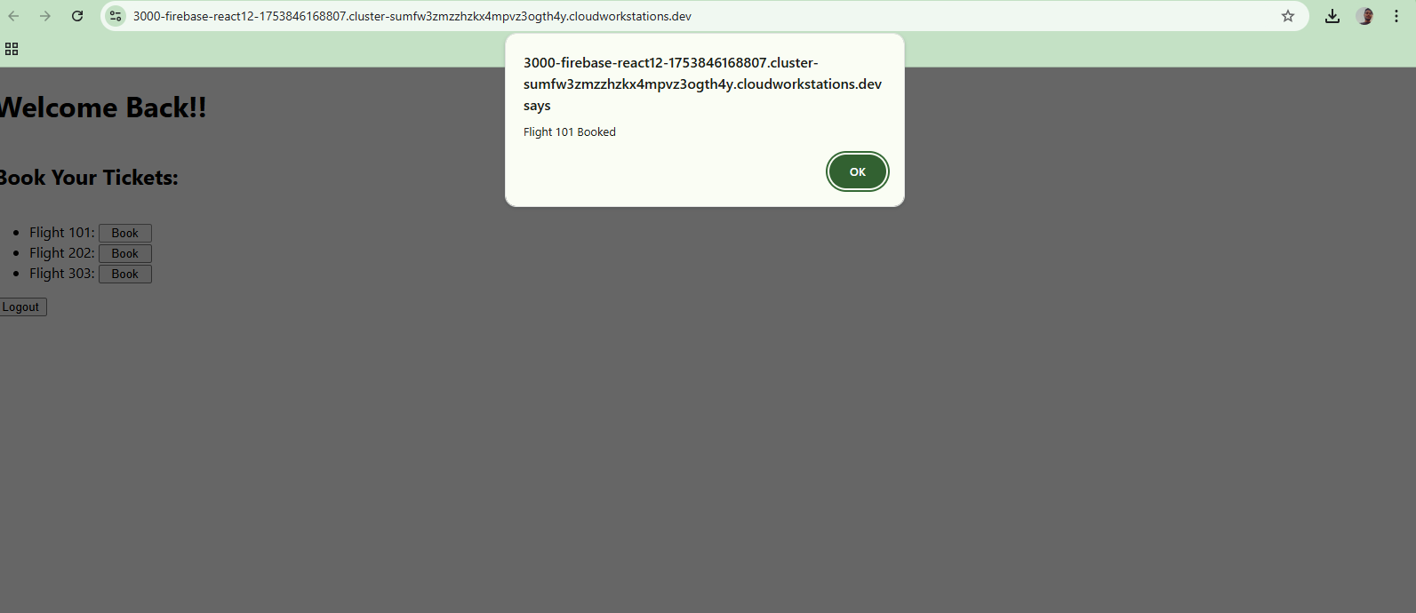

**13.ReactJS - HOL**  
  
Create a React App named “bloggerapp” in with 3 components.

1. Book Details
2. Blog Details
3. Course Details

Implement this with as many ways possible of Conditional Rendering.

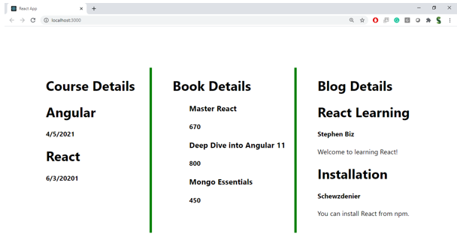

**Hint:**

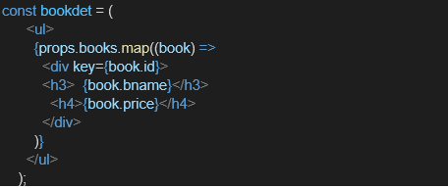

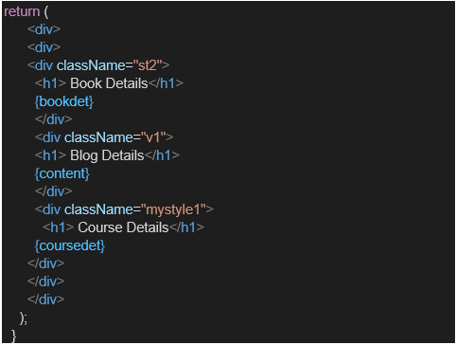

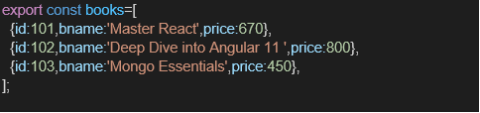

**Source Code:**  
  
**BlogDetails.js:**

function BlogDetails(props){

return(

<>

<h1>

Blog Details

</h1>

{

props.data.map((item,index)=>{

return(

<div key={index}>

<h2>{item.title}</h2>

<h3>{item.author}</h3>

<h5>{item.summary}</h5>

</div>

)

})

}

</>

)

}

export default BlogDetails;

**BookDetails.js:**

function BookDetails(props){

return(

<>

<h1>

Book Details

</h1>

{

props.data.map((item,index)=>{

return(

<div key={index}>

<h2>{item.BookTitle}</h2>

<h5>{item.price}</h5>

</div>

)

})

}

</>

)

}

export default BookDetails;

**CourseDetails.js:**

function CourseDetails(props){

return(

<>

<h1>

Course Details

</h1>

{

props.data.map((item,index)=>{

return(

<div key={index}>

<h2>{item.Coursename}</h2>

<h5>{item.date}</h5>

</div>

)

})

}

</>

)

}

export default CourseDetails;

**App.js:**

**1.Logical AND(&&) Conditional Rendering:**

import './App.css';

import BlogDetails from './BlogDetails';

import BookDetails from './BookDetails';

import CourseDetails from './CourseDetails';

import {useState} from 'react'

function App() {

const [buttons,setButton]=useState("")

const courses=[{Coursename:"Angular",date:"4/5/2021"},{Coursename:"React",date:"6/3/2021"}]

const books=[{BookTitle:"React",price:670},{BookTitle:"Deep Dive into Angular 11",price:800},{BookTitle:"Mongo Essentials",price:450}]

const blogs = [

{

title: "React Learning",

author: "Stephen Biz",

summary: "Welcome to learning React!"

},

{

title: "Installation",

author: "Schwezdenier",

summary: "You can install React from npm."

}

];

return (

<div className="App">

<button onClick={()=>setButton("blog")}>Blog Details</button>

<button onClick={()=>setButton("book")}>Book Details</button>

<button onClick={()=>setButton("course")}>Course Details</button>

{buttons==="blog" && <BlogDetails data={blogs}/>}

{buttons==="book" && <BookDetails data={books}/>}

{buttons==="course" && <CourseDetails data={courses}/>}

</div>

);

}

export default App;

**2.Ternary Conditional Rendering:**  
import './App.css';

import BlogDetails from './BlogDetails';

import BookDetails from './BookDetails';

import CourseDetails from './CourseDetails';

import { useState } from 'react';

function App() {

const [buttons, setButton] = useState("");

const courses = [

{ Coursename: "Angular", date: "4/5/2021" },

{ Coursename: "React", date: "6/3/2021" }

];

const books = [

{ BookTitle: "React", price: 670 },

{ BookTitle: "Deep Dive into Angular 11", price: 800 },

{ BookTitle: "Mongo Essentials", price: 450 }

];

const blogs = [

{

title: "React Learning",

author: "Stephen Biz",

summary: "Welcome to learning React!"

},

{

title: "Installation",

author: "Schwezdenier",

summary: "You can install React from npm."

}

];

return (

<div className="App">

<button onClick={() => setButton("blog")}>Blog Details</button>

<button onClick={() => setButton("book")}>Book Details</button>

<button onClick={() => setButton("course")}>Course Details</button>

{

buttons === "blog" ? (

<BlogDetails data={blogs} />

) : buttons === "book" ? (

<BookDetails data={books} />

) : (

<CourseDetails data={courses} />

)

}

</div>

);

}

export default App;

**3.If-Else Conditional Rendering:**  
  
import './App.css';

import BlogDetails from './BlogDetails';

import BookDetails from './BookDetails';

import CourseDetails from './CourseDetails';

import { useState } from 'react';

function App() {

const [buttons, setButton] = useState("");

const courses = [

{ Coursename: "Angular", date: "4/5/2021" },

{ Coursename: "React", date: "6/3/2021" }

];

const books = [

{ BookTitle: "React", price: 670 },

{ BookTitle: "Deep Dive into Angular 11", price: 800 },

{ BookTitle: "Mongo Essentials", price: 450 }

];

const blogs = [

{

title: "React Learning",

author: "Stephen Biz",

summary: "Welcome to learning React!"

},

{

title: "Installation",

author: "Schwezdenier",

summary: "You can install React from npm."

}

];

let content;

if (buttons === "blog") {

content = <BlogDetails data={blogs} />;

} else if (buttons === "book") {

content = <BookDetails data={books} />;

} else if (buttons === "course") {

content = <CourseDetails data={courses} />;

}

return (

<div className="App">

<button onClick={() => setButton("blog")}>Blog Details</button>

<button onClick={() => setButton("book")}>Book Details</button>

<button onClick={() => setButton("course")}>Course Details</button>

{content}

</div>

);

}

export default App;

**4.Switch Case Conditional Rendering:**  
  
import './App.css';

import BlogDetails from './BlogDetails';

import BookDetails from './BookDetails';

import CourseDetails from './CourseDetails';

import { useState } from 'react';

function App() {

const [buttons, setButton] = useState("");

const courses = [

{ Coursename: "Angular", date: "4/5/2021" },

{ Coursename: "React", date: "6/3/2021" }

];

const books = [

{ BookTitle: "React", price: 670 },

{ BookTitle: "Deep Dive into Angular 11", price: 800 },

{ BookTitle: "Mongo Essentials", price: 450 }

];

const blogs = [

{

title: "React Learning",

author: "Stephen Biz",

summary: "Welcome to learning React!"

},

{

title: "Installation",

author: "Schwezdenier",

summary: "You can install React from npm."

}

];

let content;

switch (buttons) {

case "blog":

content = <BlogDetails data={blogs} />;

break;

case "book":

content = <BookDetails data={books} />;

break;

case "course":

content = <CourseDetails data={courses} />;

break;

default:

content = <p>Please select a section</p>;

}

return (

<div className="App">

<button onClick={() => setButton("blog")}>Blog Details</button>

<button onClick={() => setButton("book")}>Book Details</button>

<button onClick={() => setButton("course")}>Course Details</button>

{content}

</div>

);

}

export default App;

**Output:**  
  
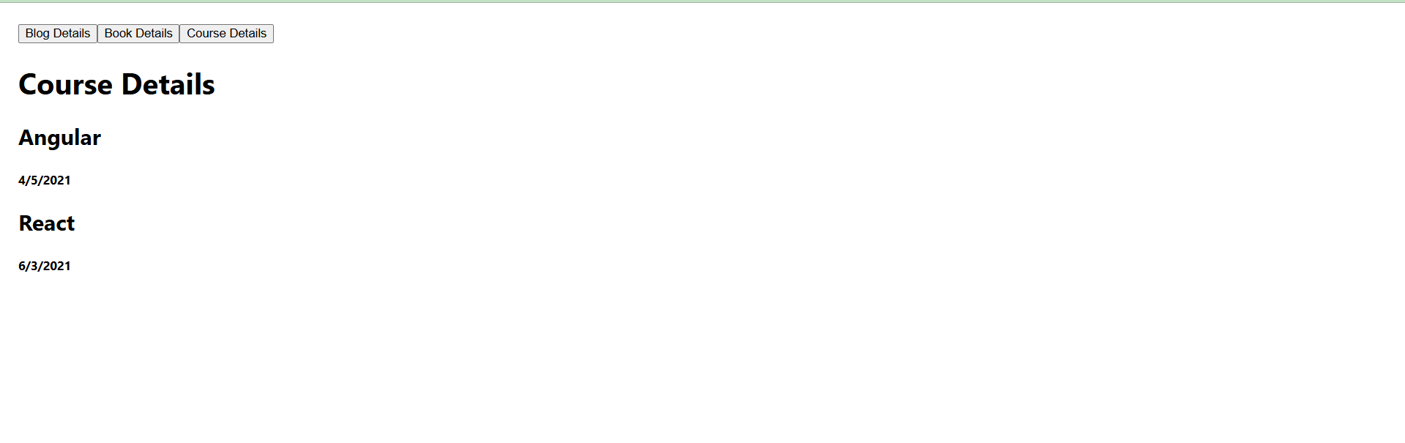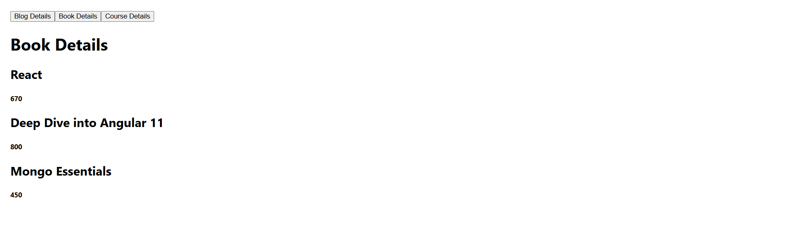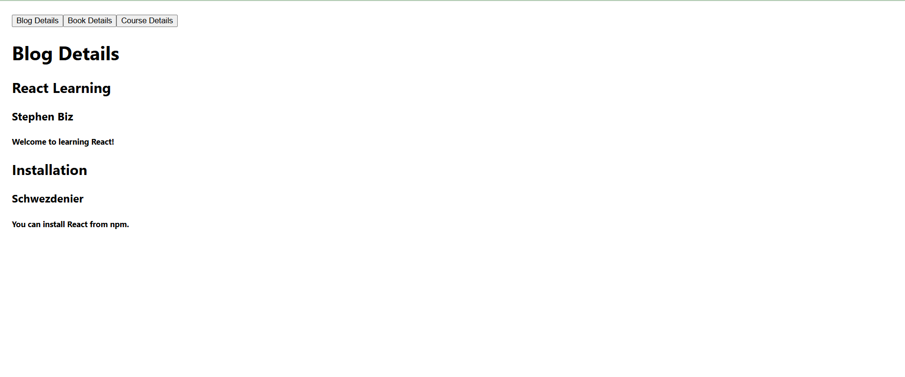

**Note :** For any type of conditional rendering, the output is similar.